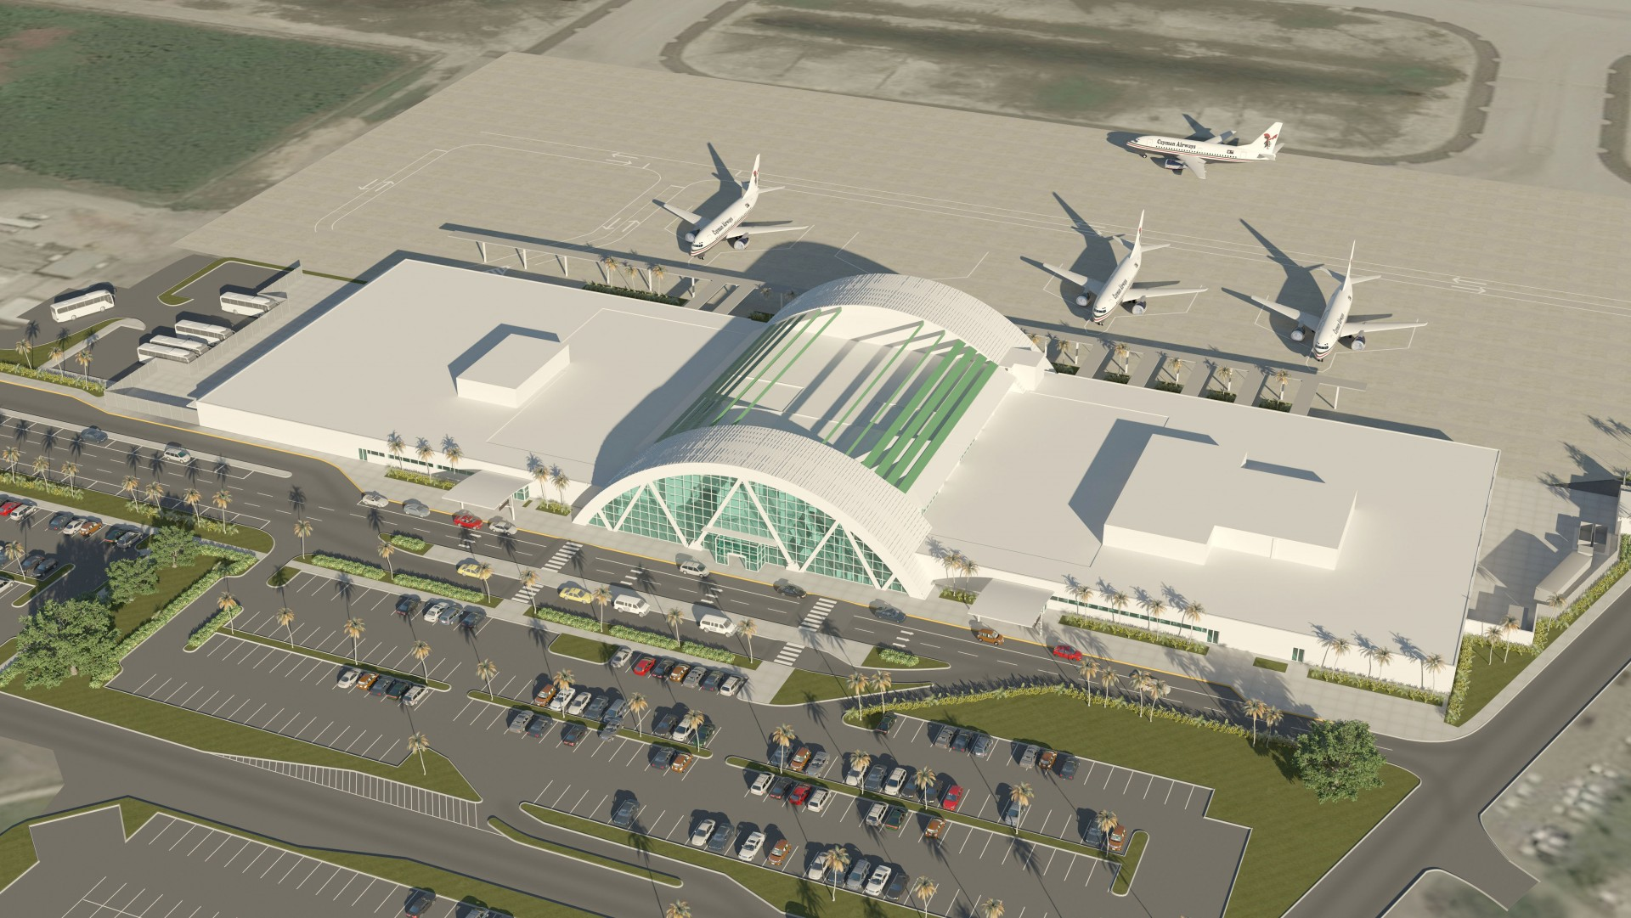

Owen Roberts International Airport <https://www.caymanairports.com/cache/homebanner/1920_700/146078081702.jpg>

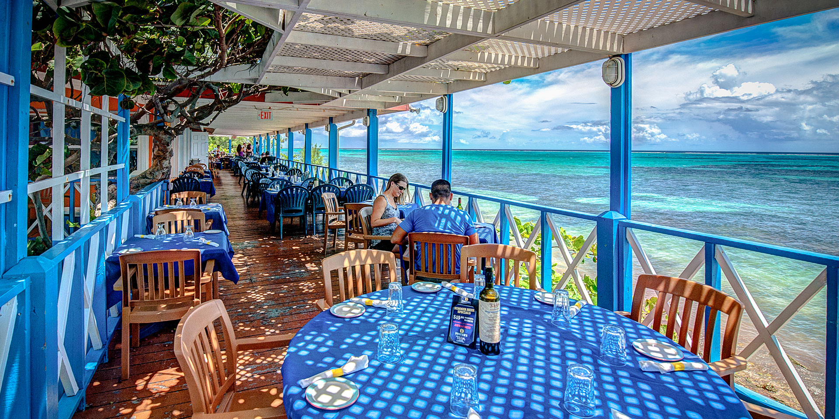

Tukka Restaurant <https://rvca738f6h5tbwmj3mxylox3-wpengine.netdna-ssl.com/wp-content/uploads/2019/07/Tukka-Balcony.jpg>

<https://www.tukka.ky> – restaurant website

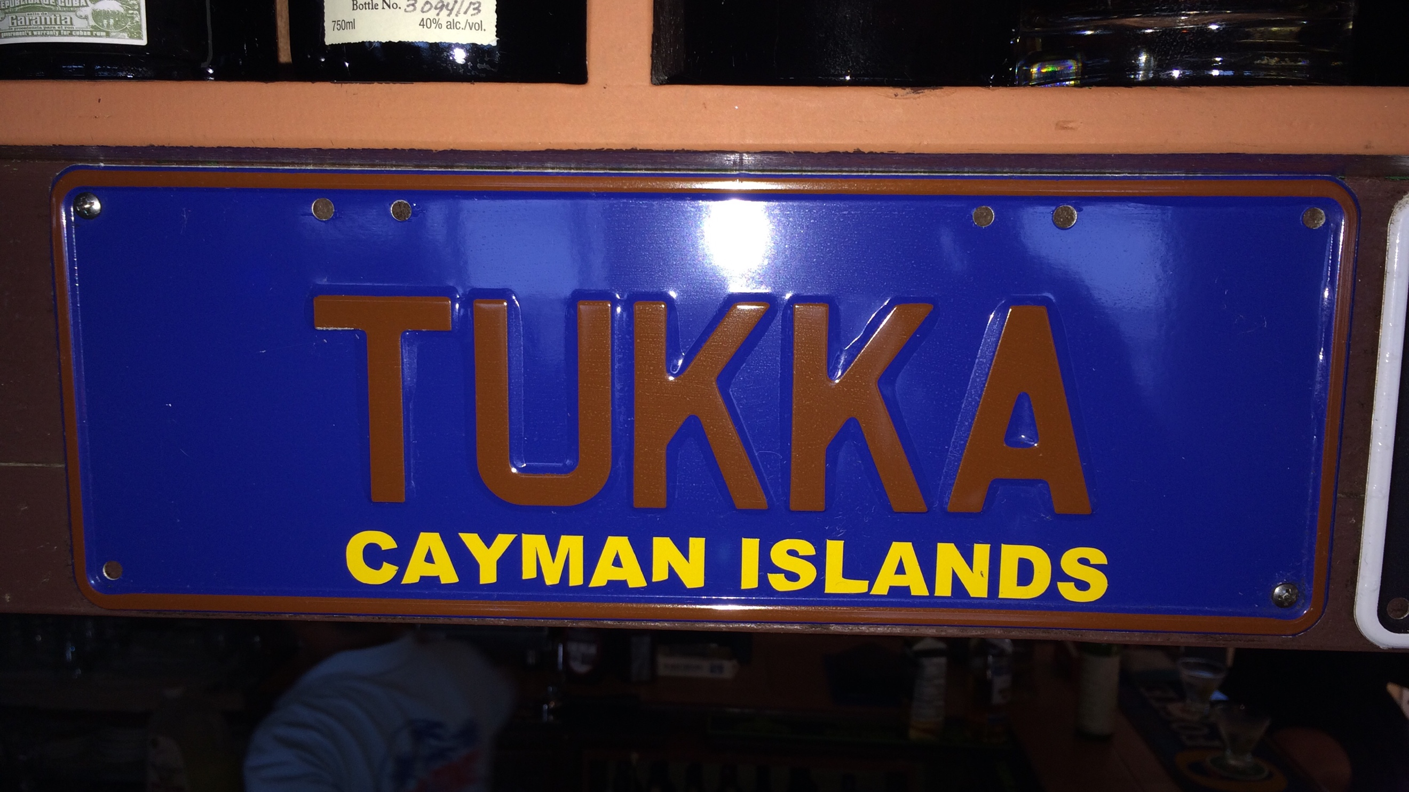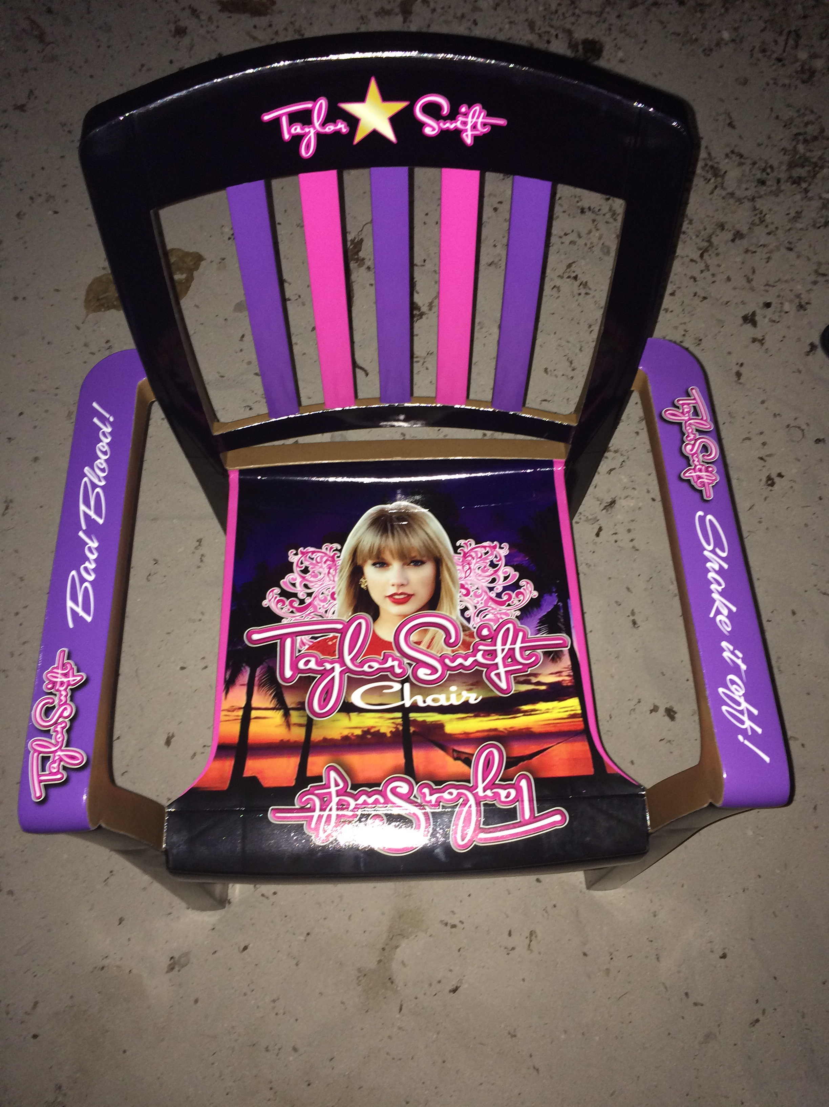 tukka – my photos

George town yacht club

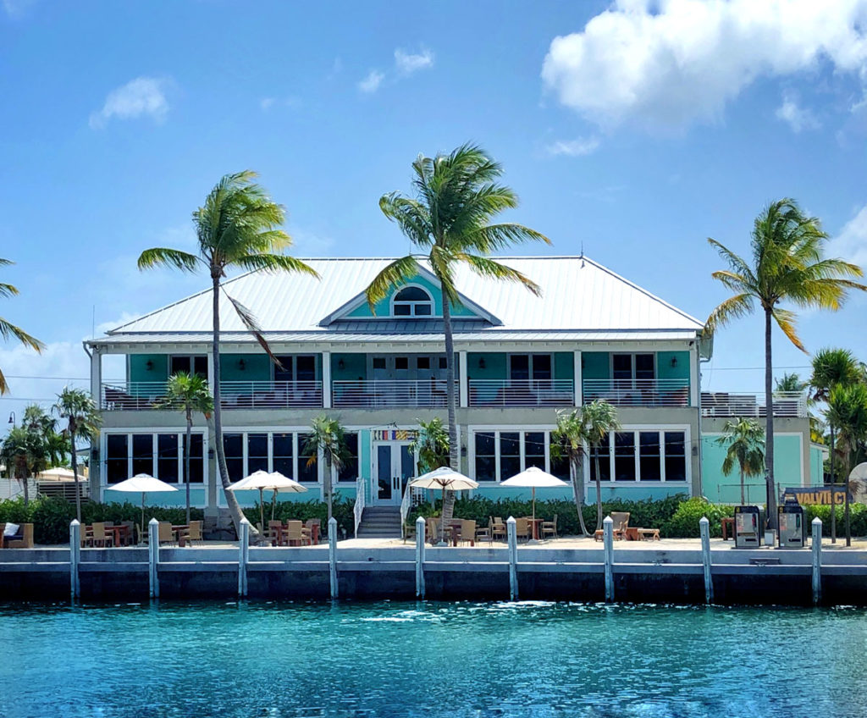

<http://www.chalmersgibbs.ky/wp-content/uploads/2019/07/GTYC-Exterior-Chalmers-Gibbs-Architects-1024x848.jpg>



<https://static1.squarespace.com/static/594c172015d5dbb061b1d202/t/59ff124953450a448c83a08a/1556987089935/?format=1500w>

restaurant website <https://www.gtyachtclub.com>

Big Tree Barbecue

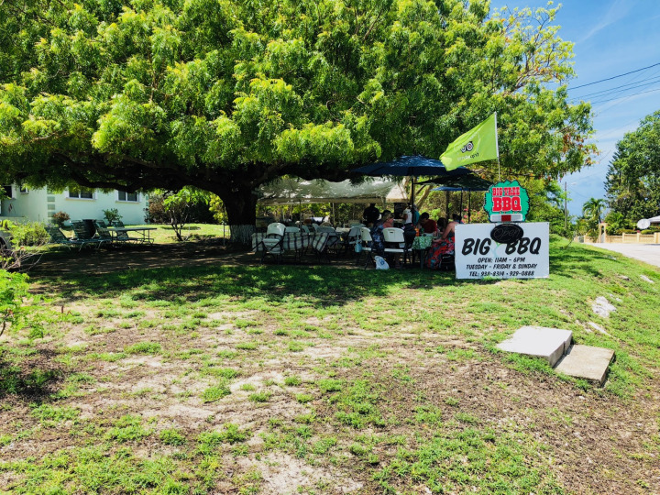

<https://johntannersbbqblog.files.wordpress.com/2018/06/big-tree-approach.jpeg?w=720>

Kurt’s Corner

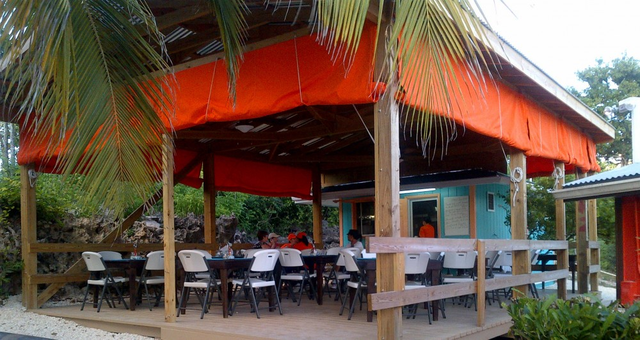

<https://www.oceanparadisecayman.com/cache/Gallery/1000_1000/kurts-korner1549733692.jpg>

The Lighthouse Restaurant

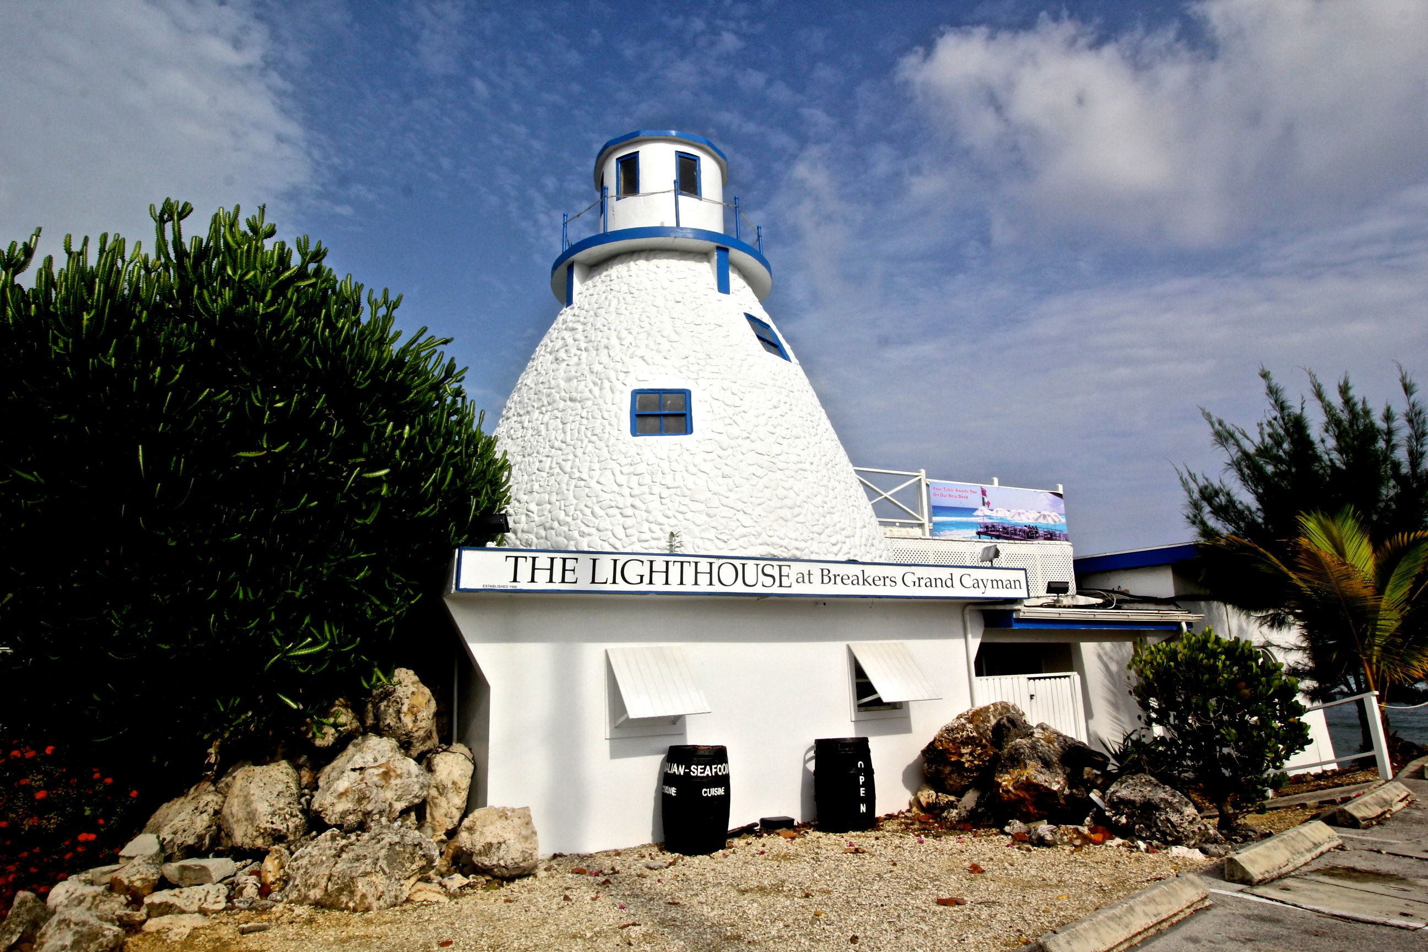

<https://wrongsideofthecamera.files.wordpress.com/2015/05/cayman-islands-lighthouse-restaurant.jpg>

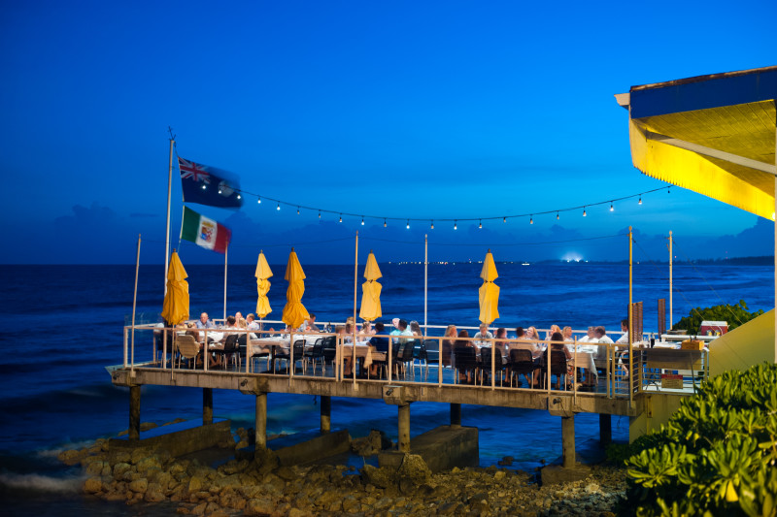

<https://assets.simpleviewinc.com/simpleview/image/upload/c_fit,w_800,h_600/crm/cayman/407_43278727_lighthouserestaurantdusk_8718_66091d19-5056-a36a-0734086d7586e9c2.jpg>

Cayman Turtle Farm

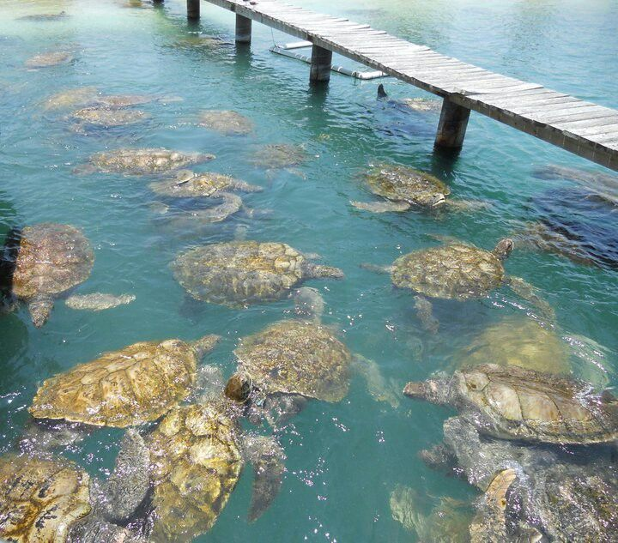

<https://i.pinimg.com/originals/1c/05/18/1c0518dcb0fd5866aa9f229d98bf6127.jpg>

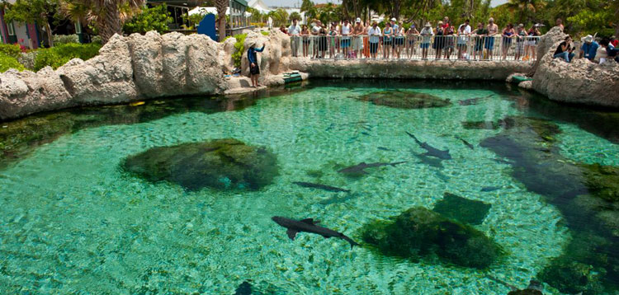

<https://www.myvacationpages.com/data/listing-images/1628459.jpg>

Stingray City

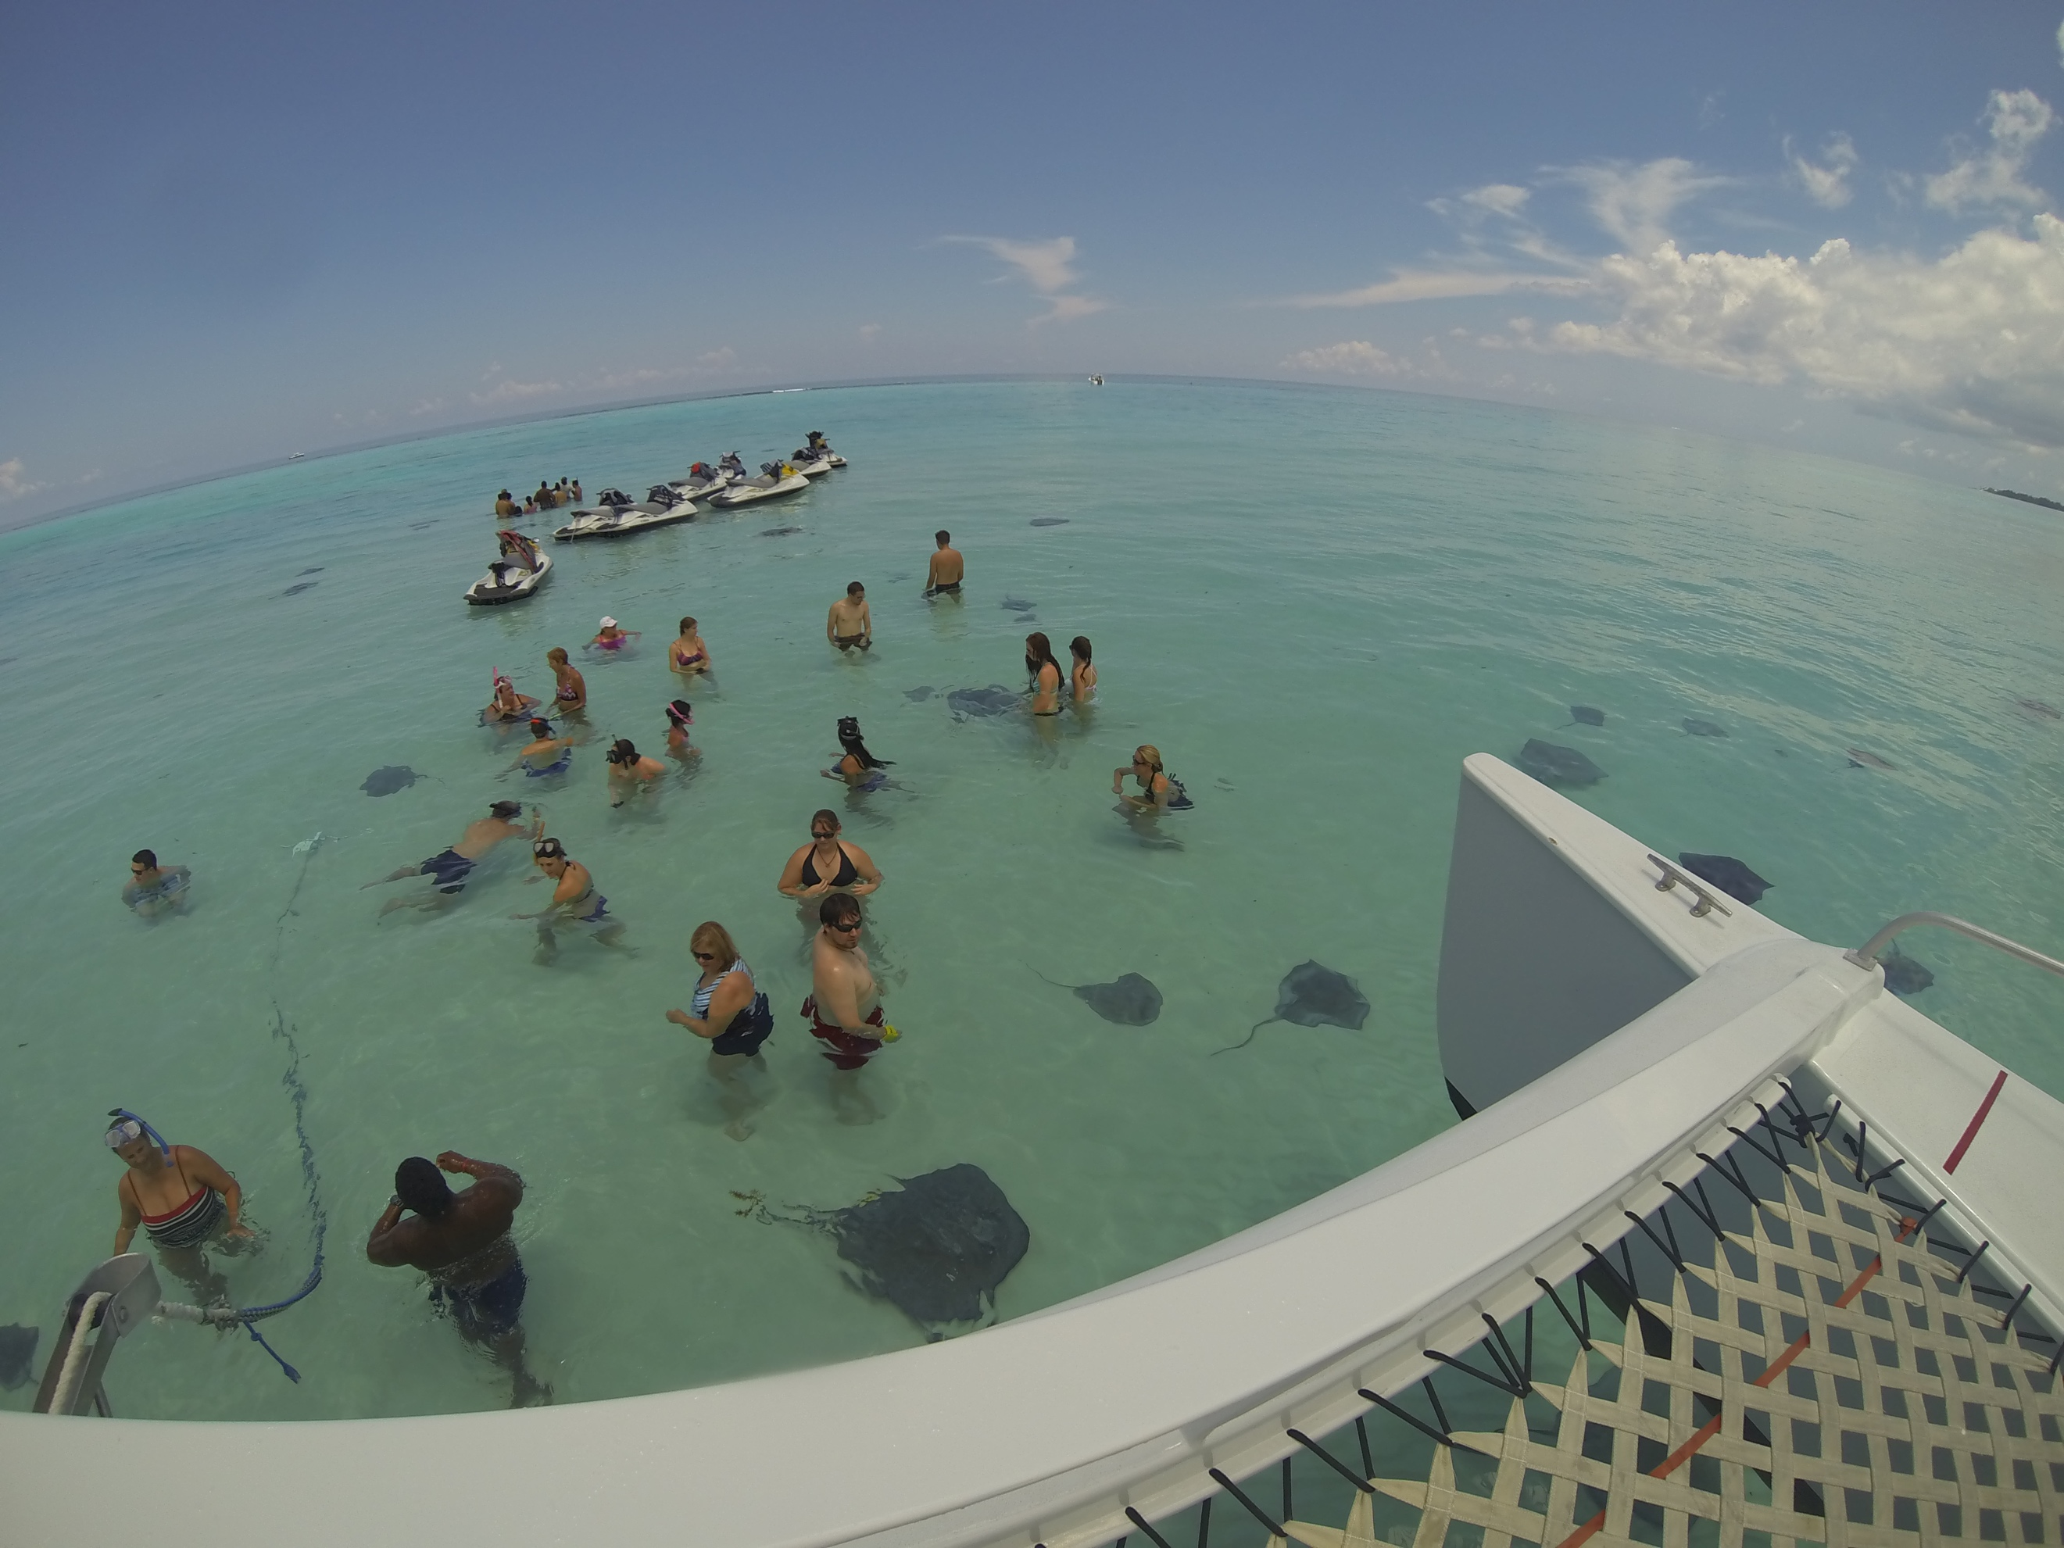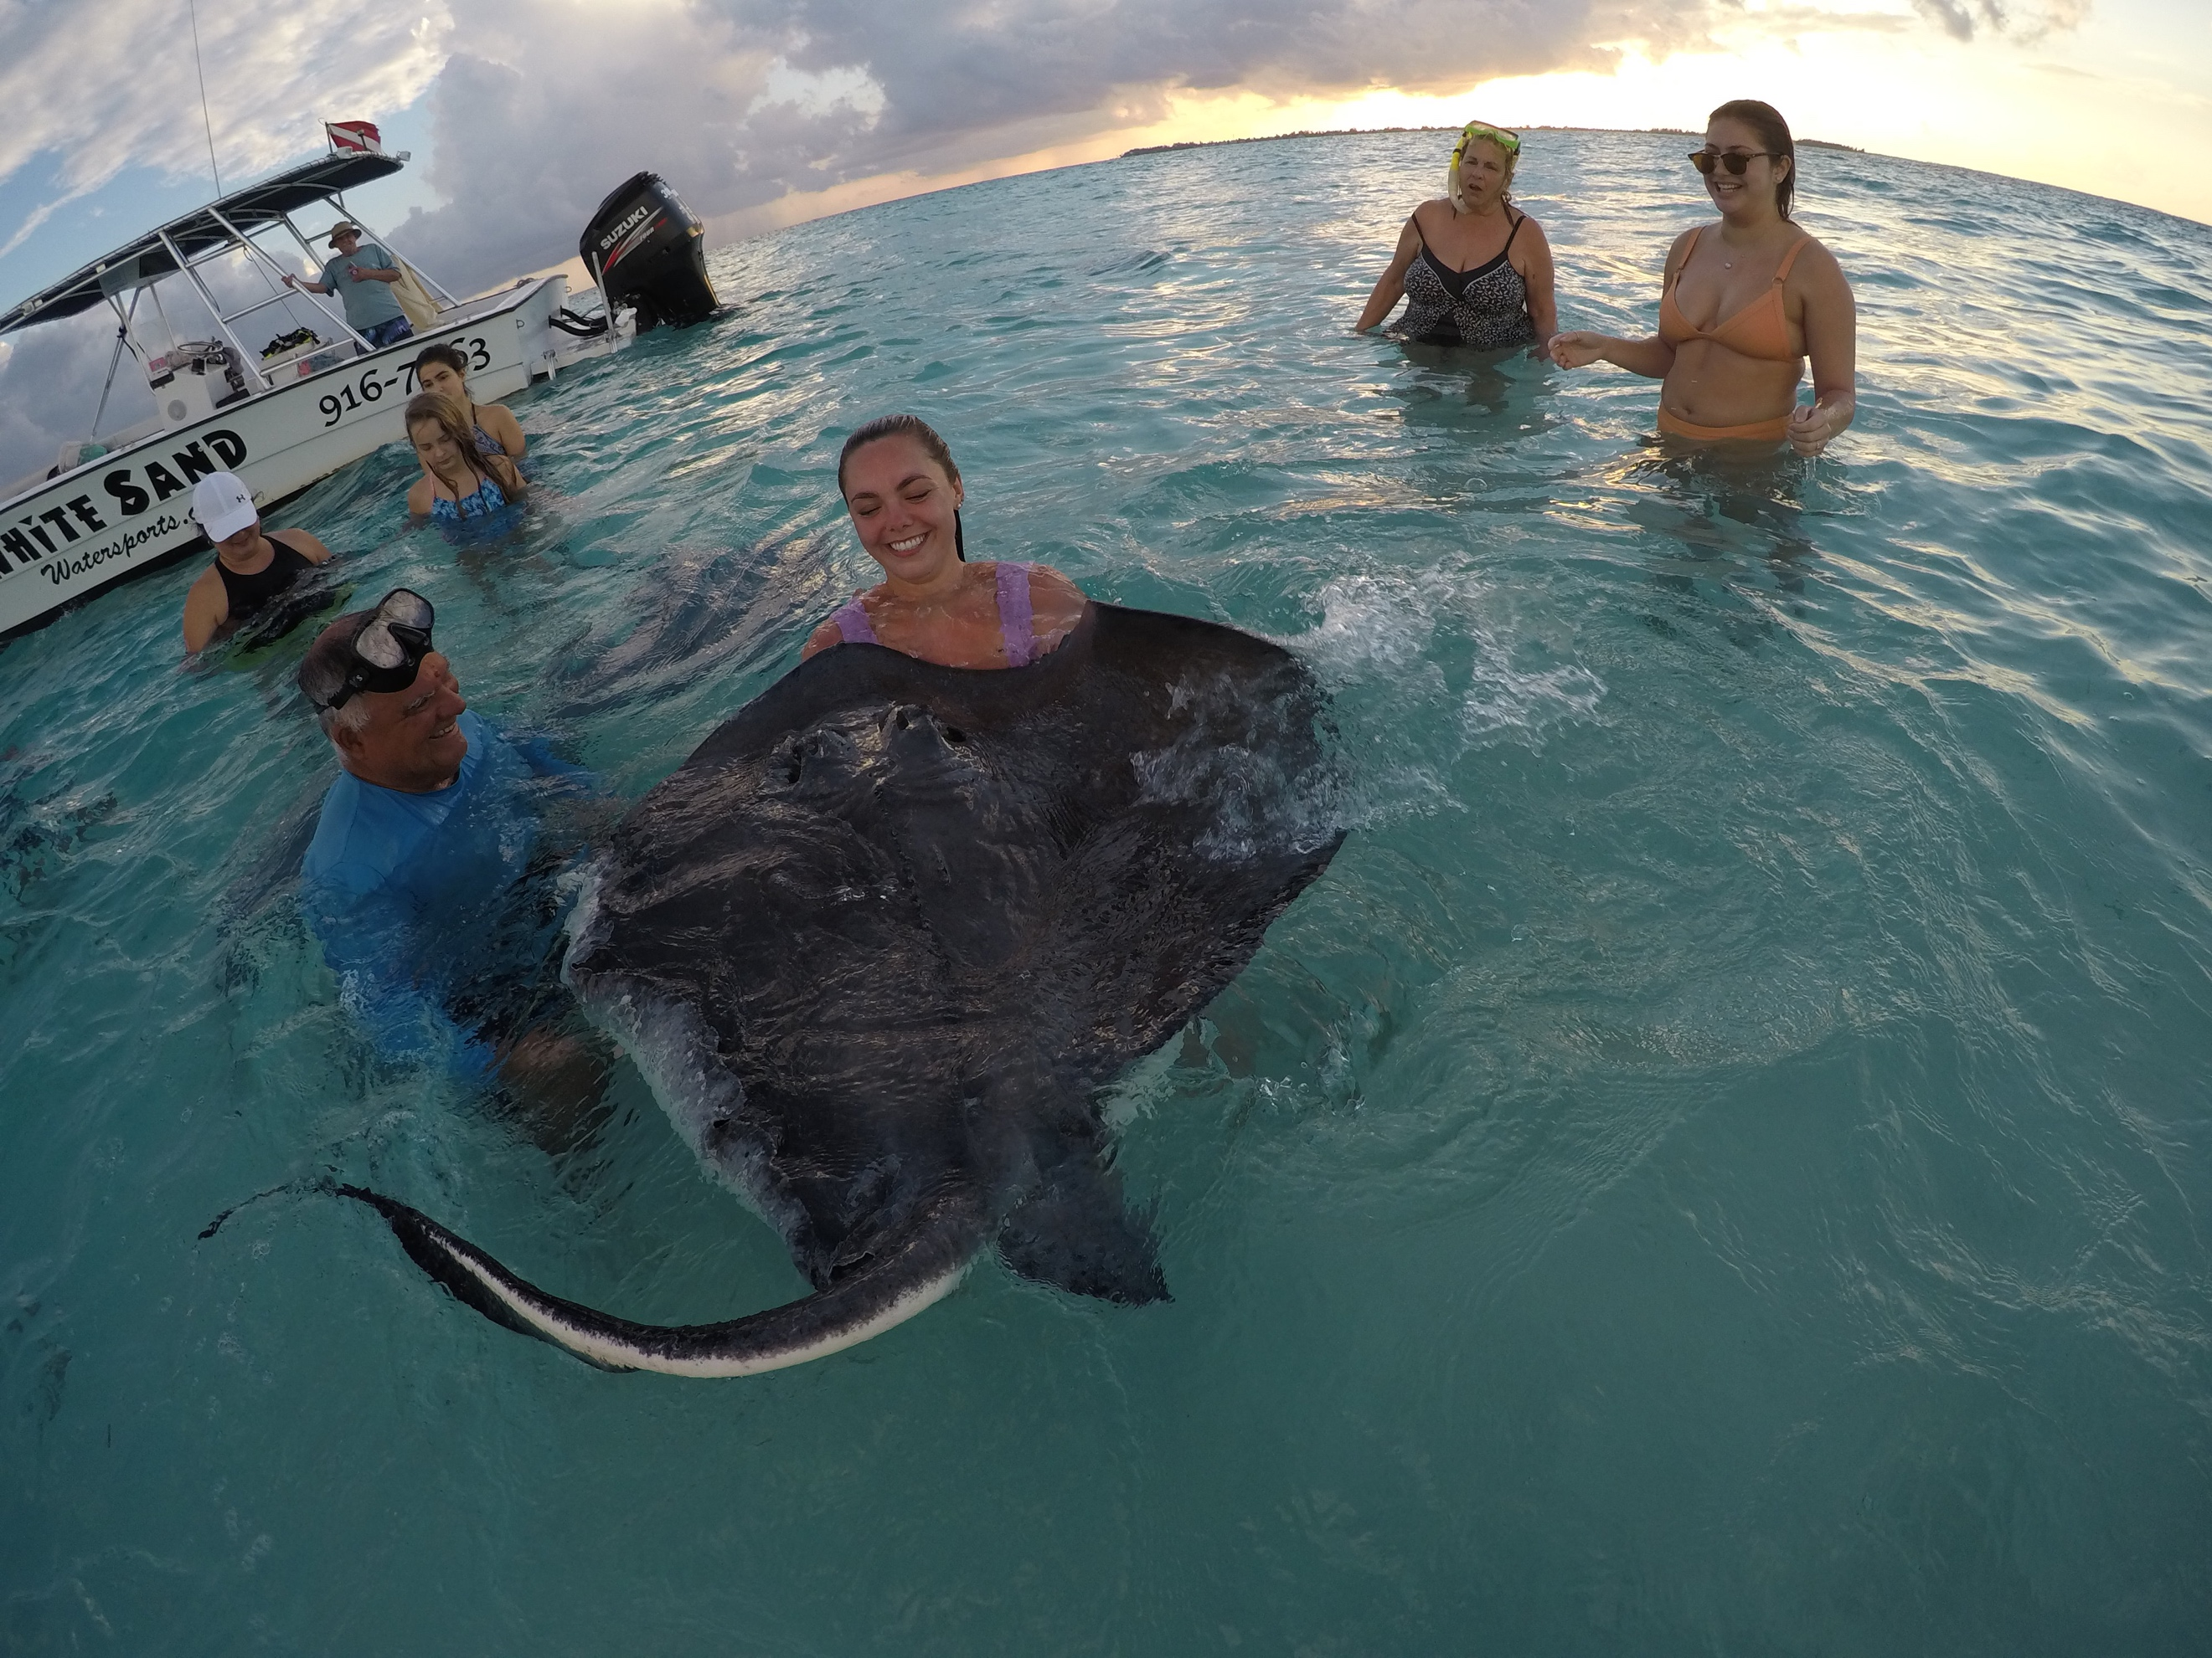

My photos

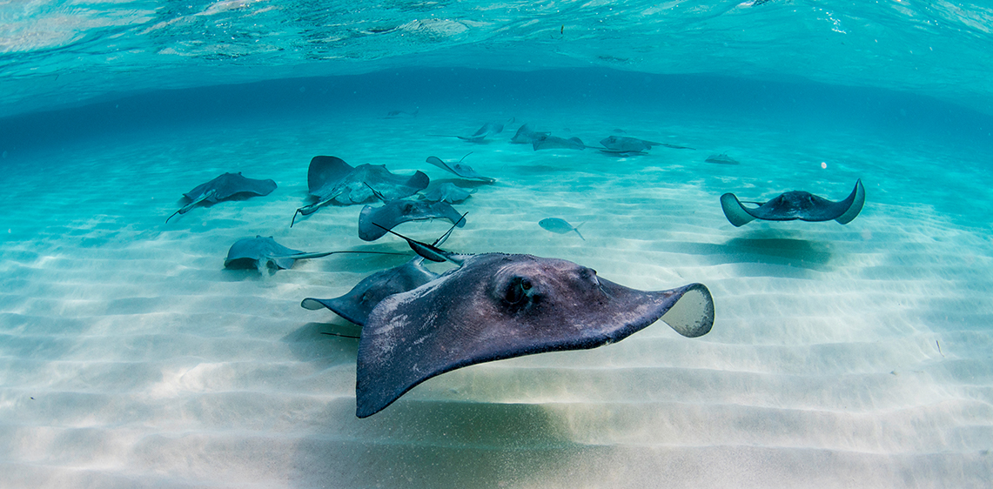

<https://cdn.visitcaymanislands.com/media/photo-galleries/popular%20attractions/stingray%20city/stingray-schooling-sandbar-2.jpg?h=220&scale=both&mode=canvas&anchor=middlecenter&bgcolor=ffffff>

video <https://youtu.be/8MTZUENCtRs>

Horseback Ride & Swim

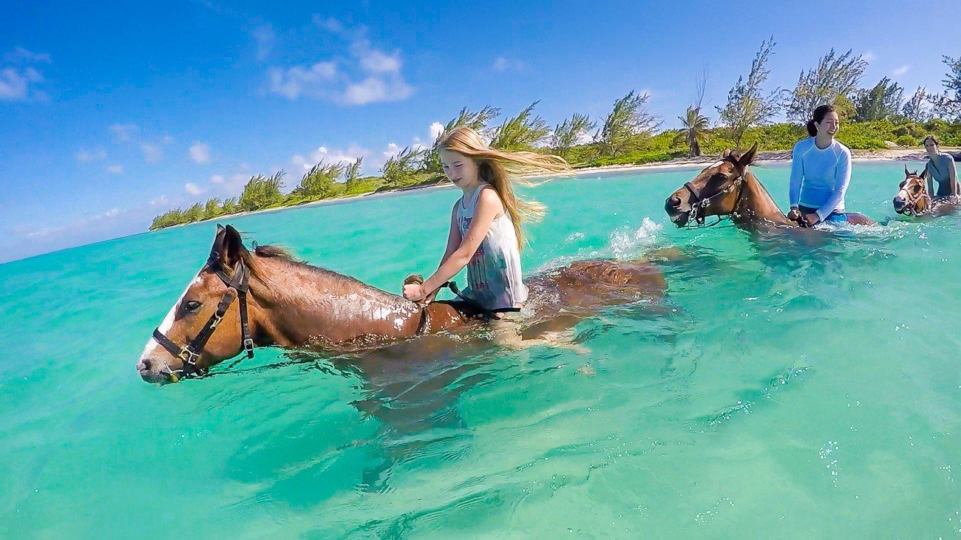

<https://lajollamom.com/wp-content/uploads/2016/09/pampered-ponies-grand-cayman-tour.jpg>

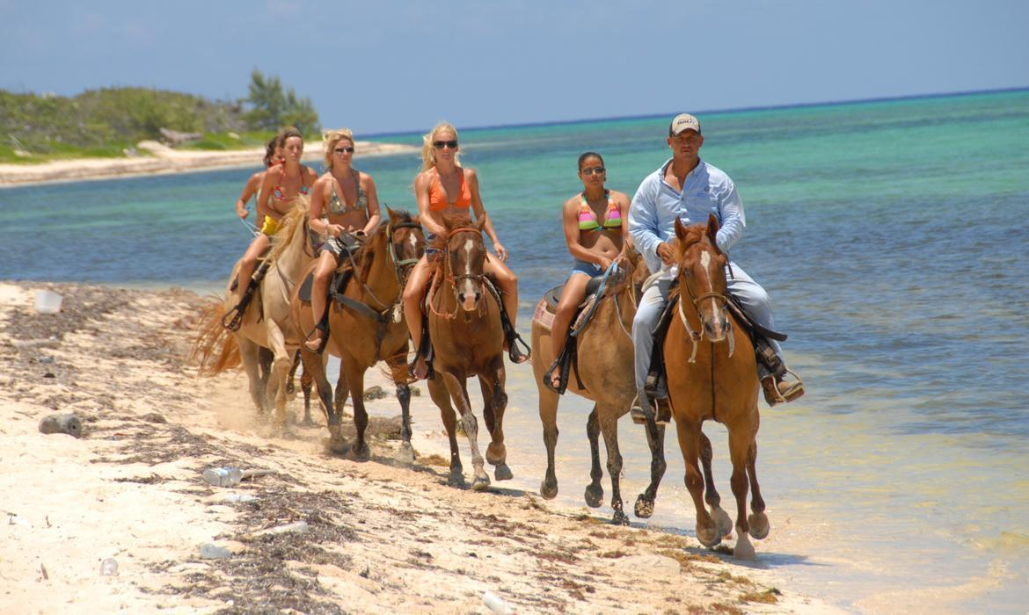

https://www.explorecayman.com/cache/photogallery/images/1170_450/1543953624~@~Spirit_of_the_West_1170x700.jpg

video - <https://youtu.be/ozTFW4ljc4o>

Dolphin Encounter

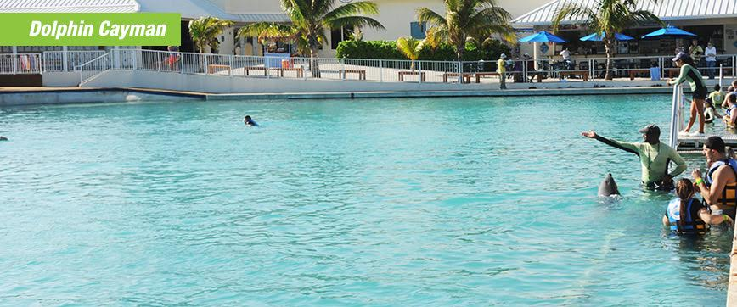

<https://www.dolphindiscovery.com/src/programs/gc/location-grand-cayman.jpg?v=7.8.19>

video - <https://youtu.be/6H52fxL1sB0>

Scuba Diving

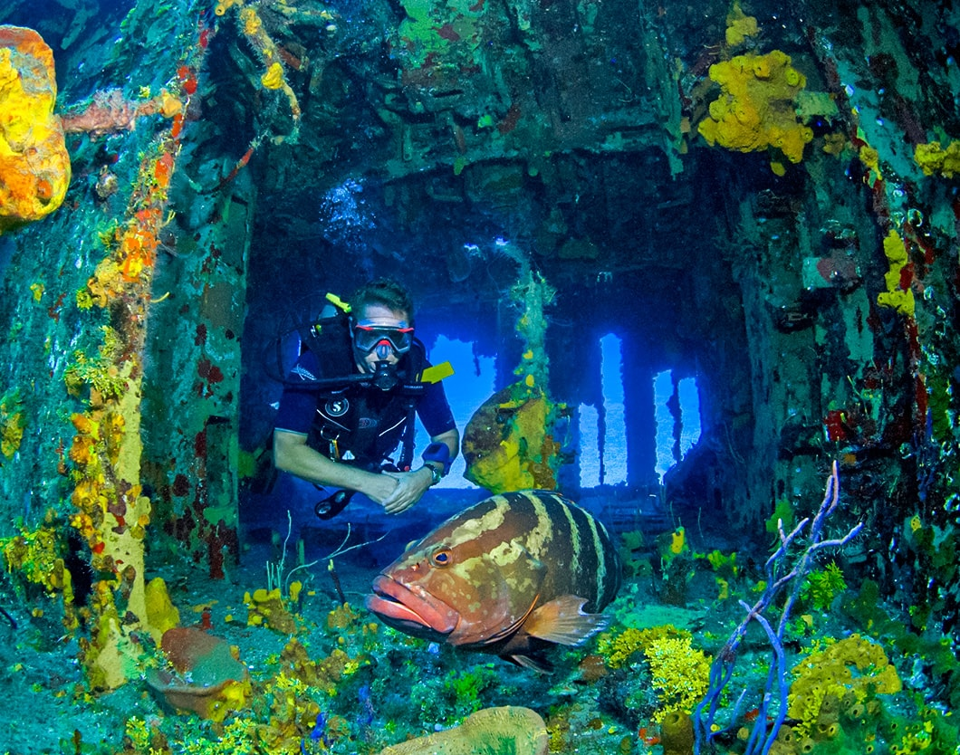

<https://www.caymanbracbeachresort.com/wp-content/uploads/sites/3/2018/02/cayman-brac-diver-grouper-in-wreck-1060x834-min.jpg>

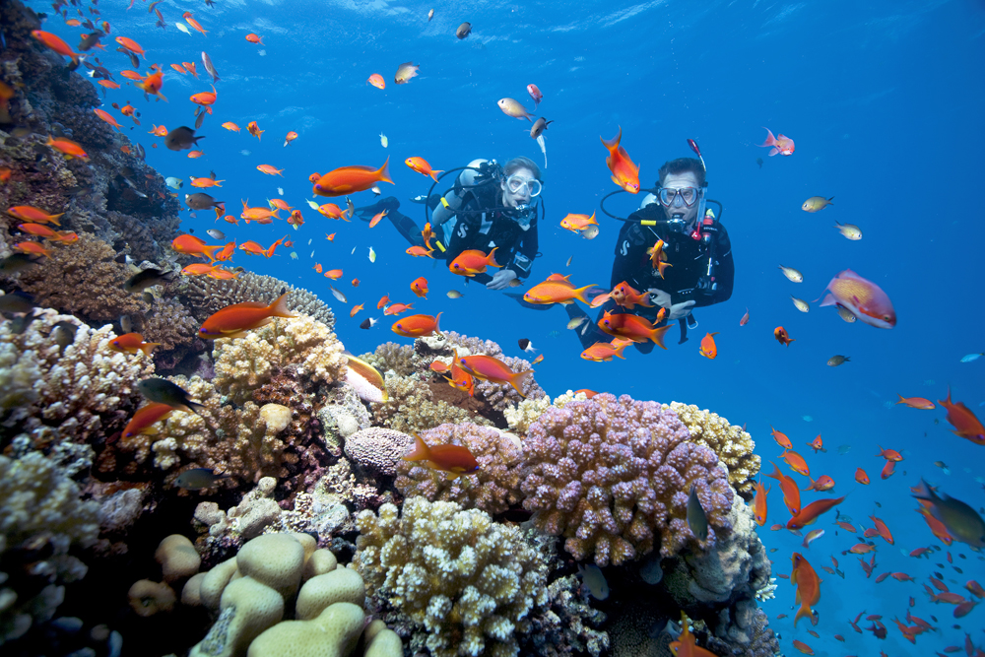

<https://dutchessscubadiving.com/wp-content/uploads/2014/10/SSI-Diving02.jpg>

video - <https://youtu.be/an1HUc8MgyI>

Where to stay

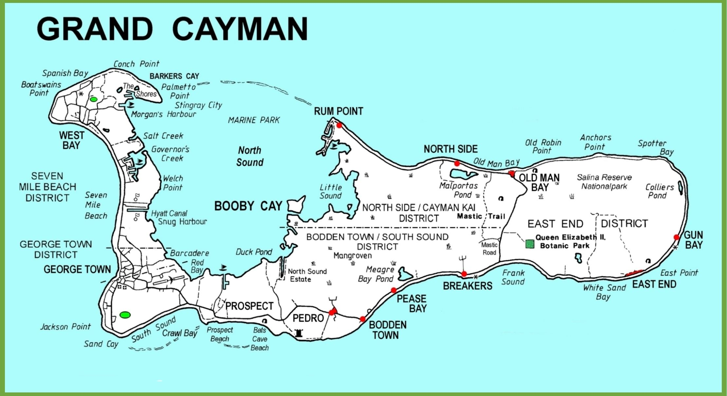

<https://i.pinimg.com/originals/a9/a2/88/a9a2883ffbdaabd3259772ca9cfa1878.jpg>

Rum Point

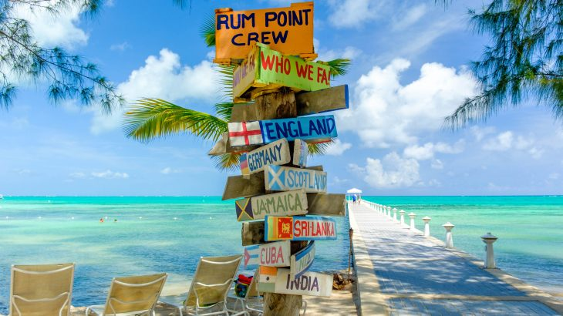

<https://www.beach.com/wp-content/uploads/2018/03/shutterstock_776650420-730x410.jpg>

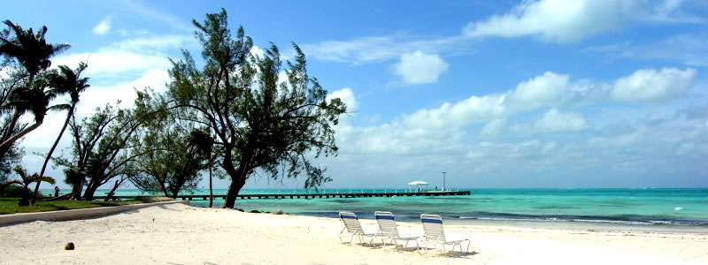

<http://grandcaymanretreat.com/wp-content/uploads/2014/10/beach_banner.jpg>

Smith Cove

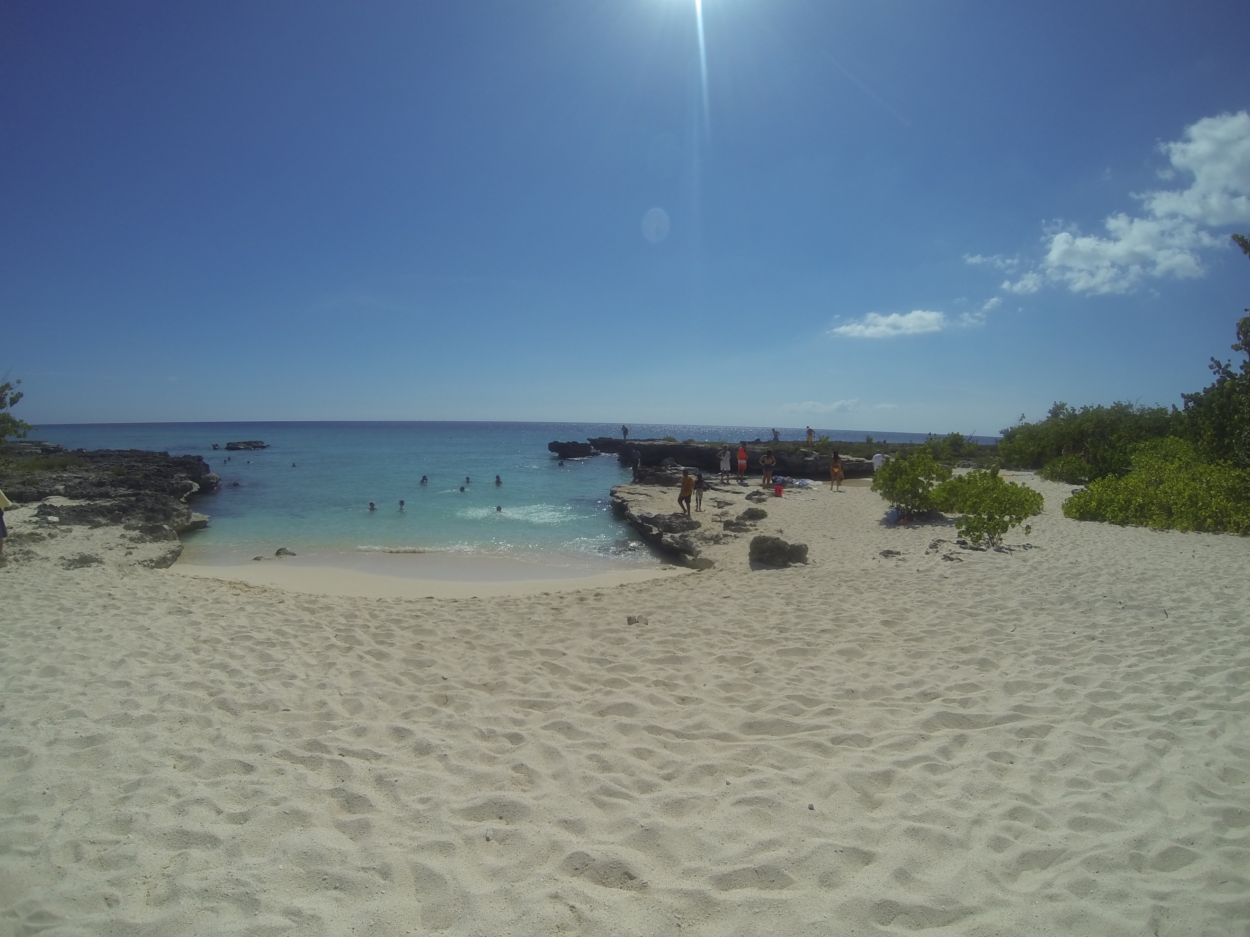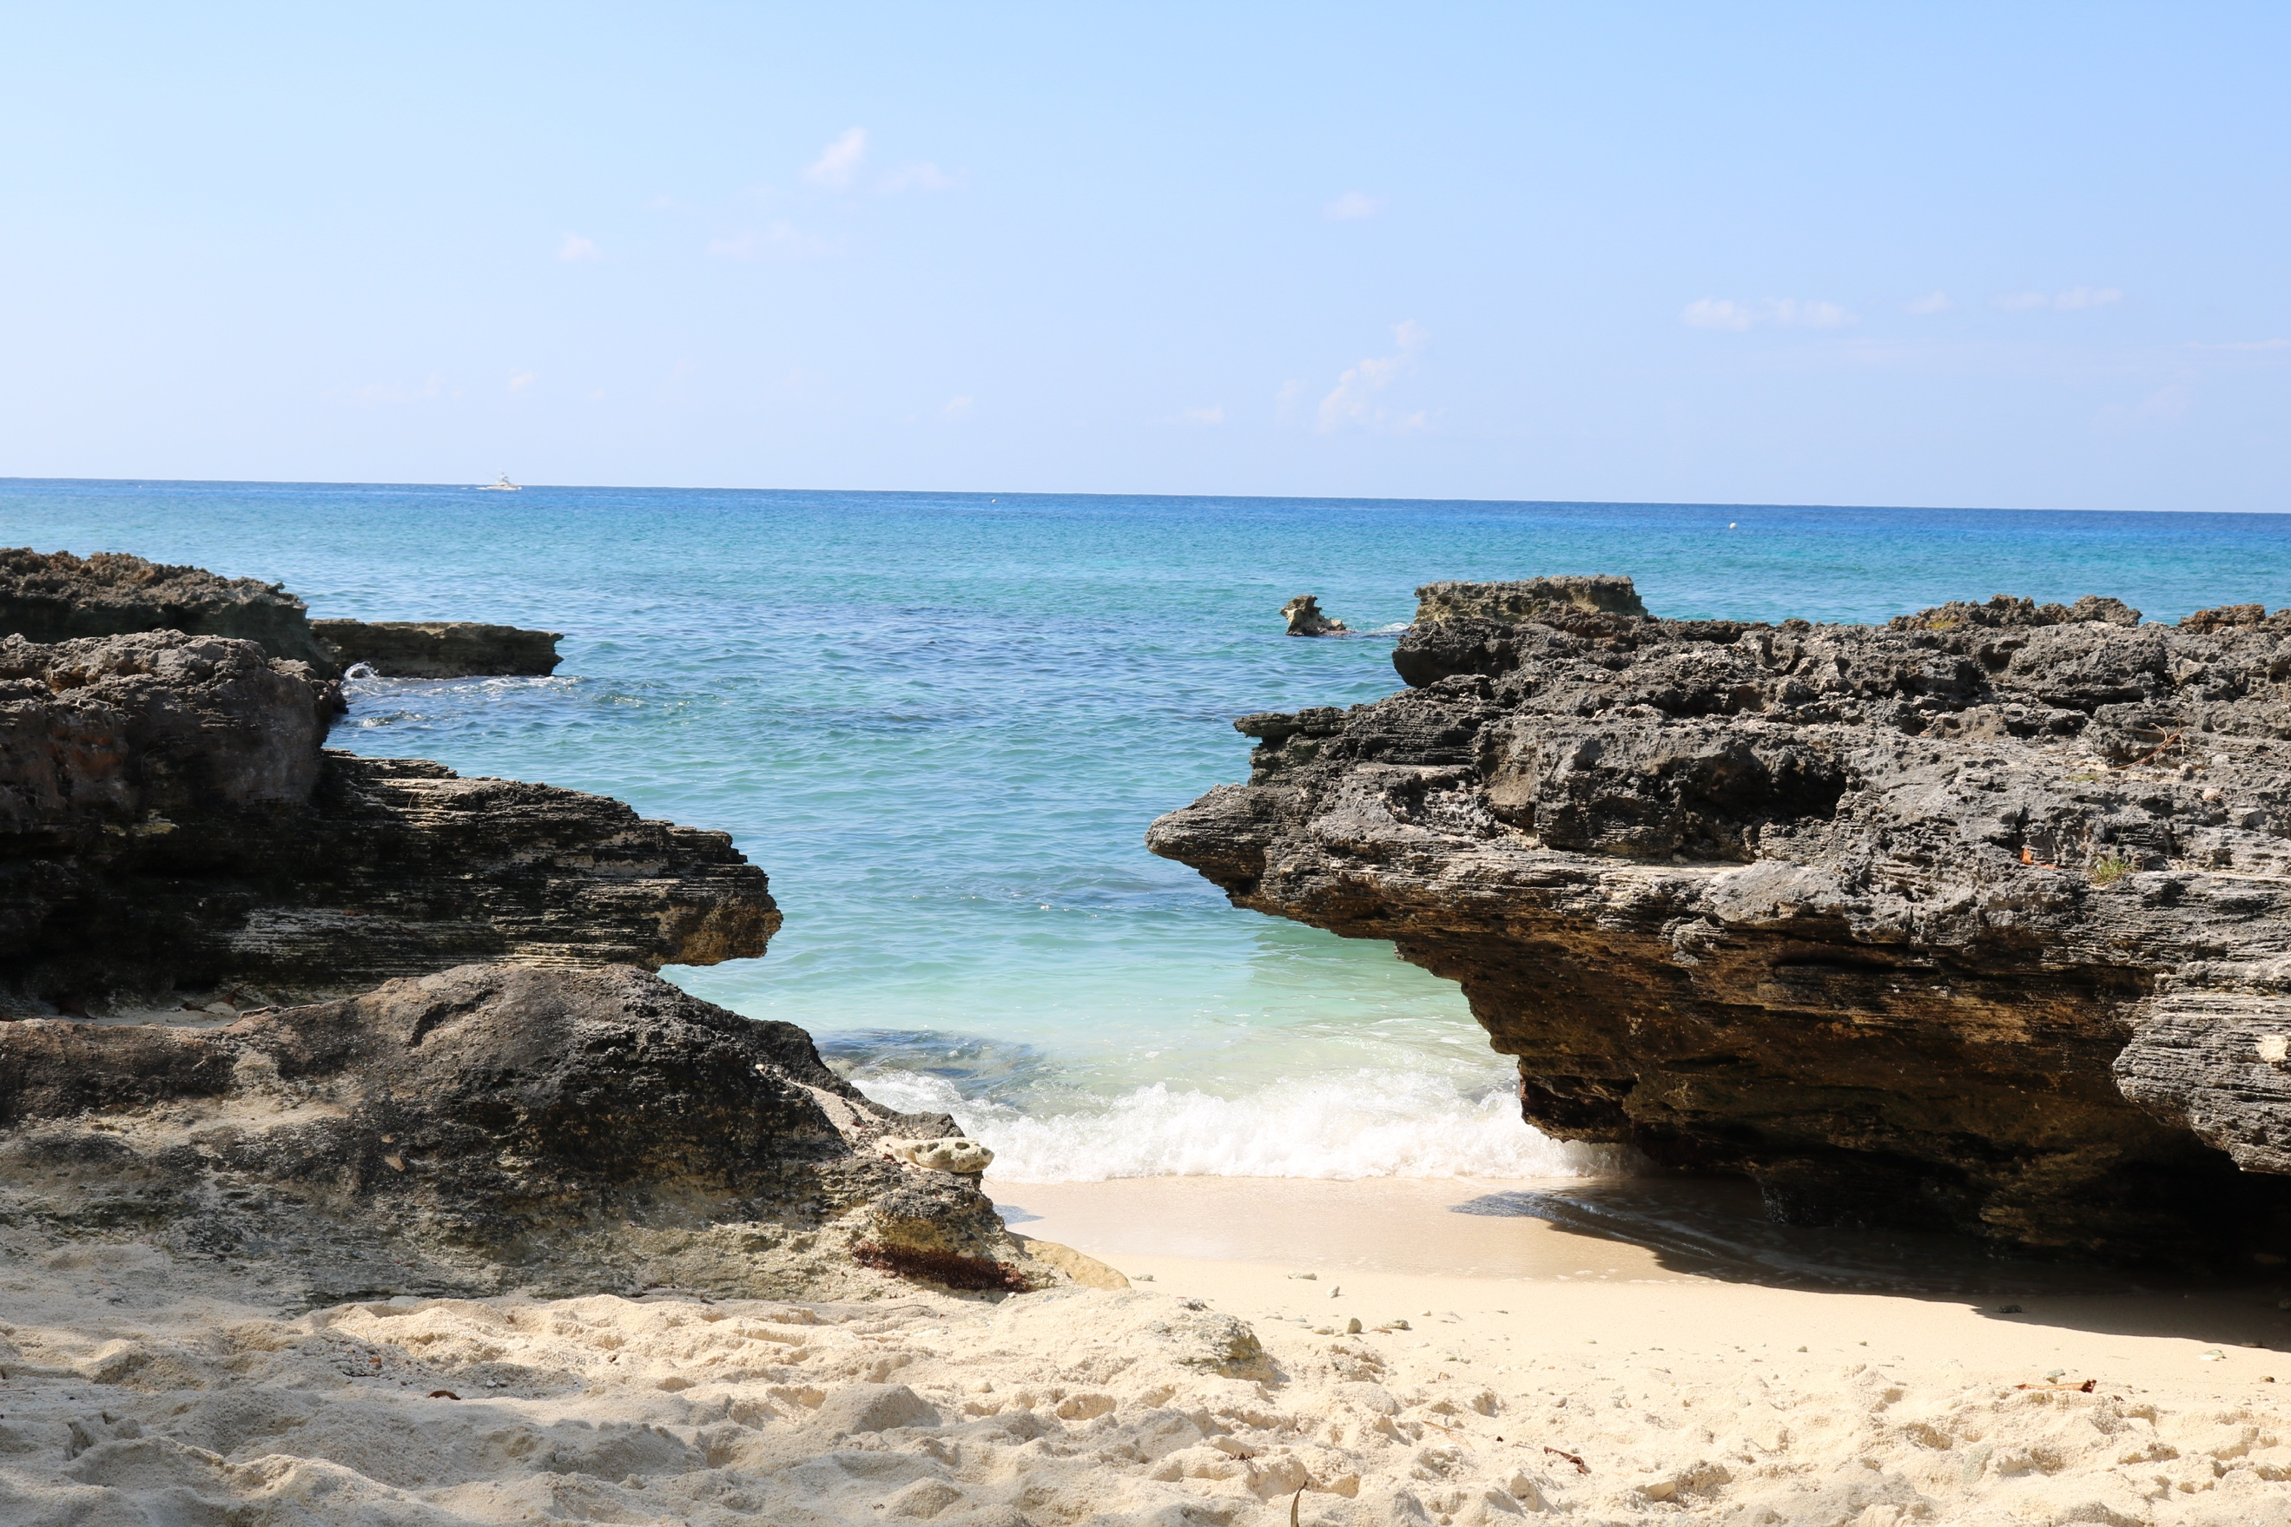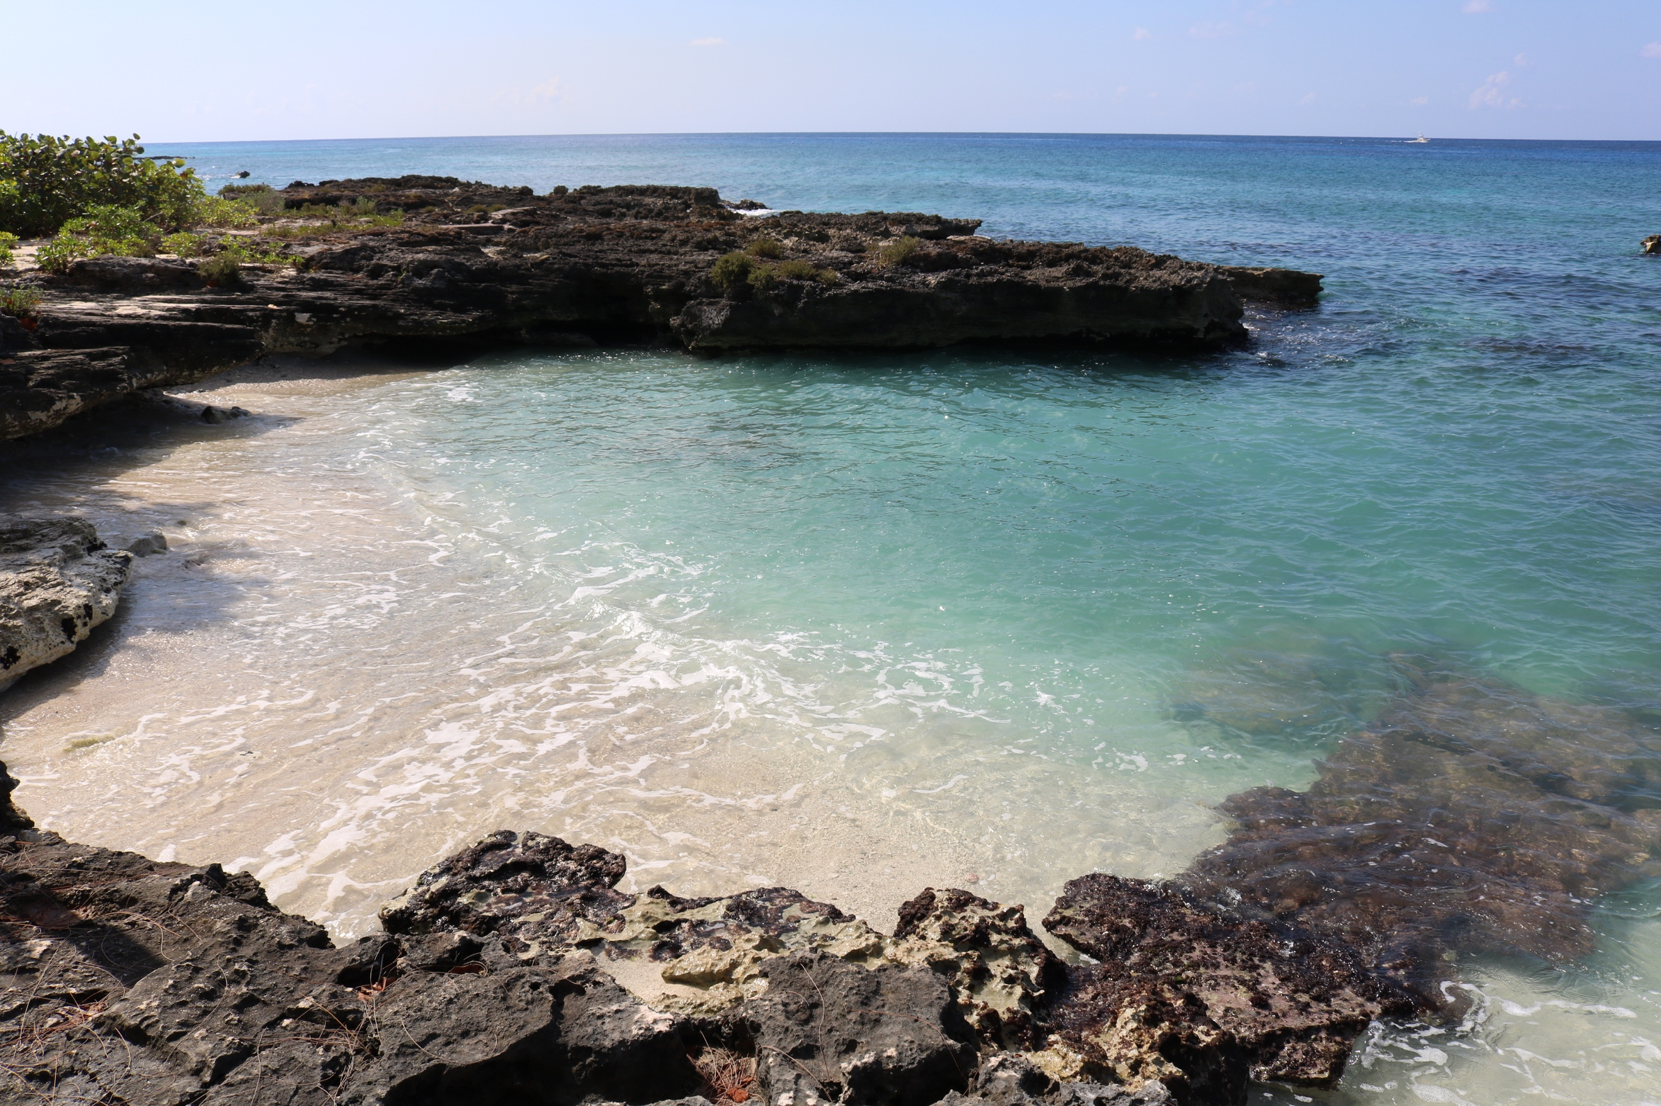

My pictures

Kaibo Beach

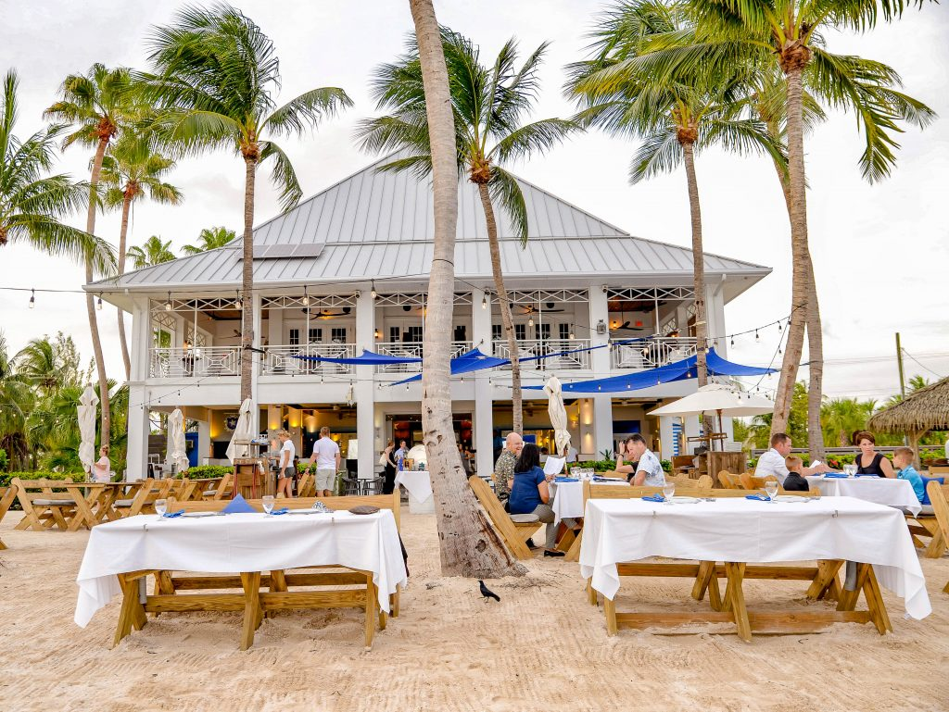

<https://lifeshelives.com/wp-content/uploads/2018/06/kaibo_luna-del-mar-1-1024x769.jpg>

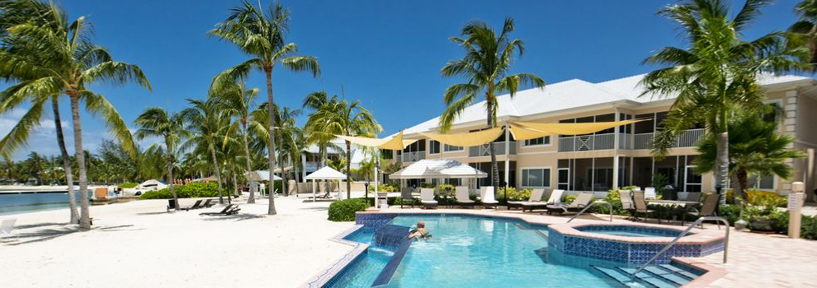

<https://caymanvacations.com/_include/img/resorts/kaibo-yacht-club.jpg>

Starfish Point

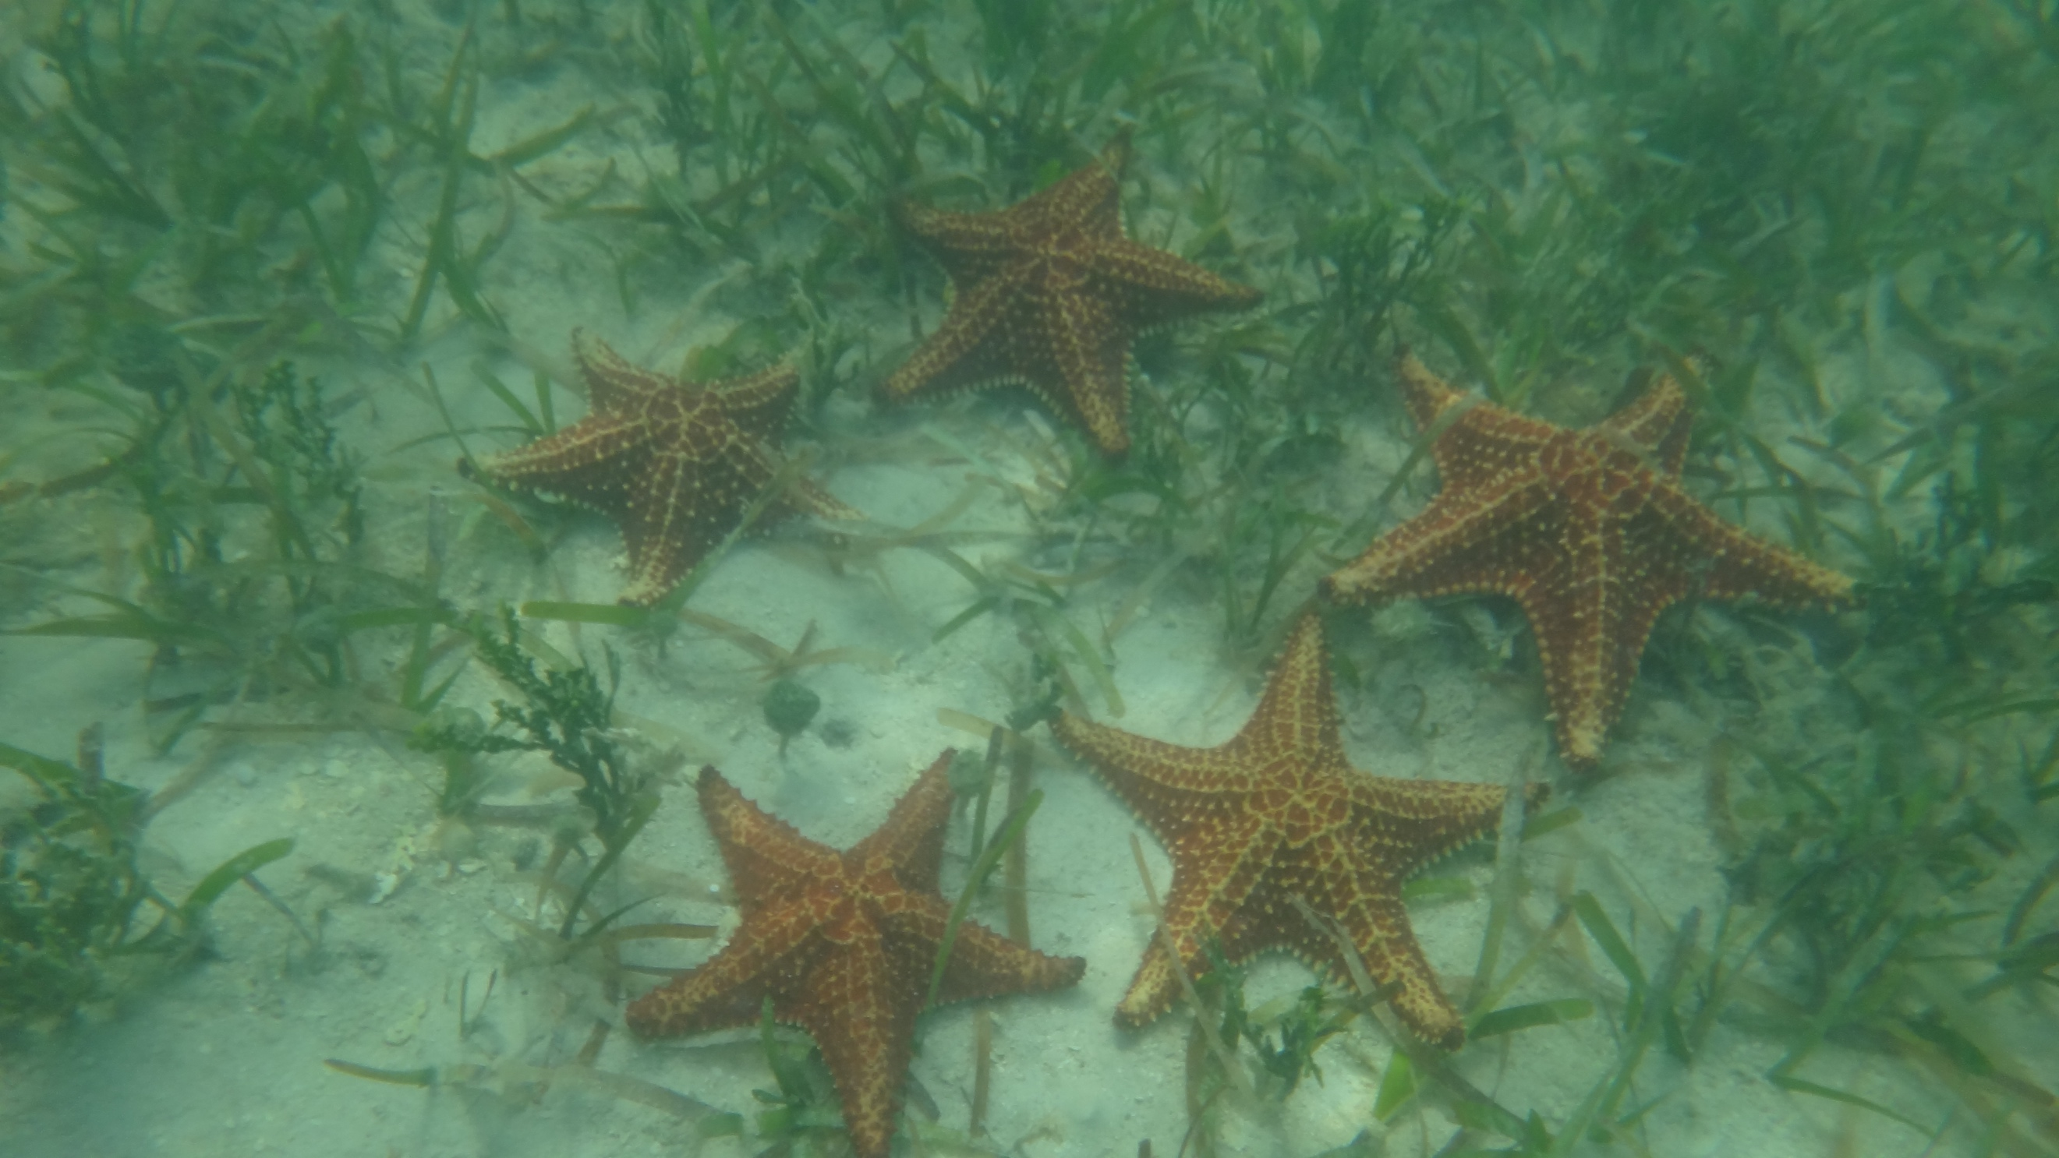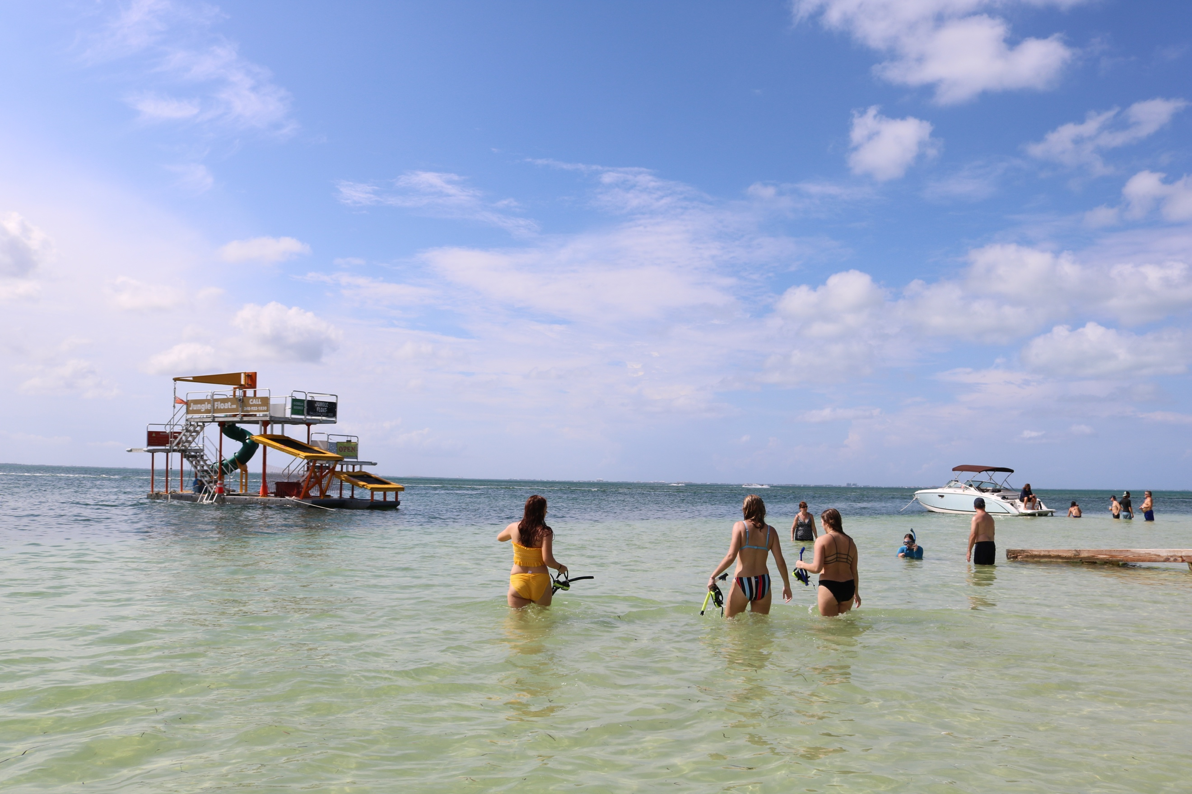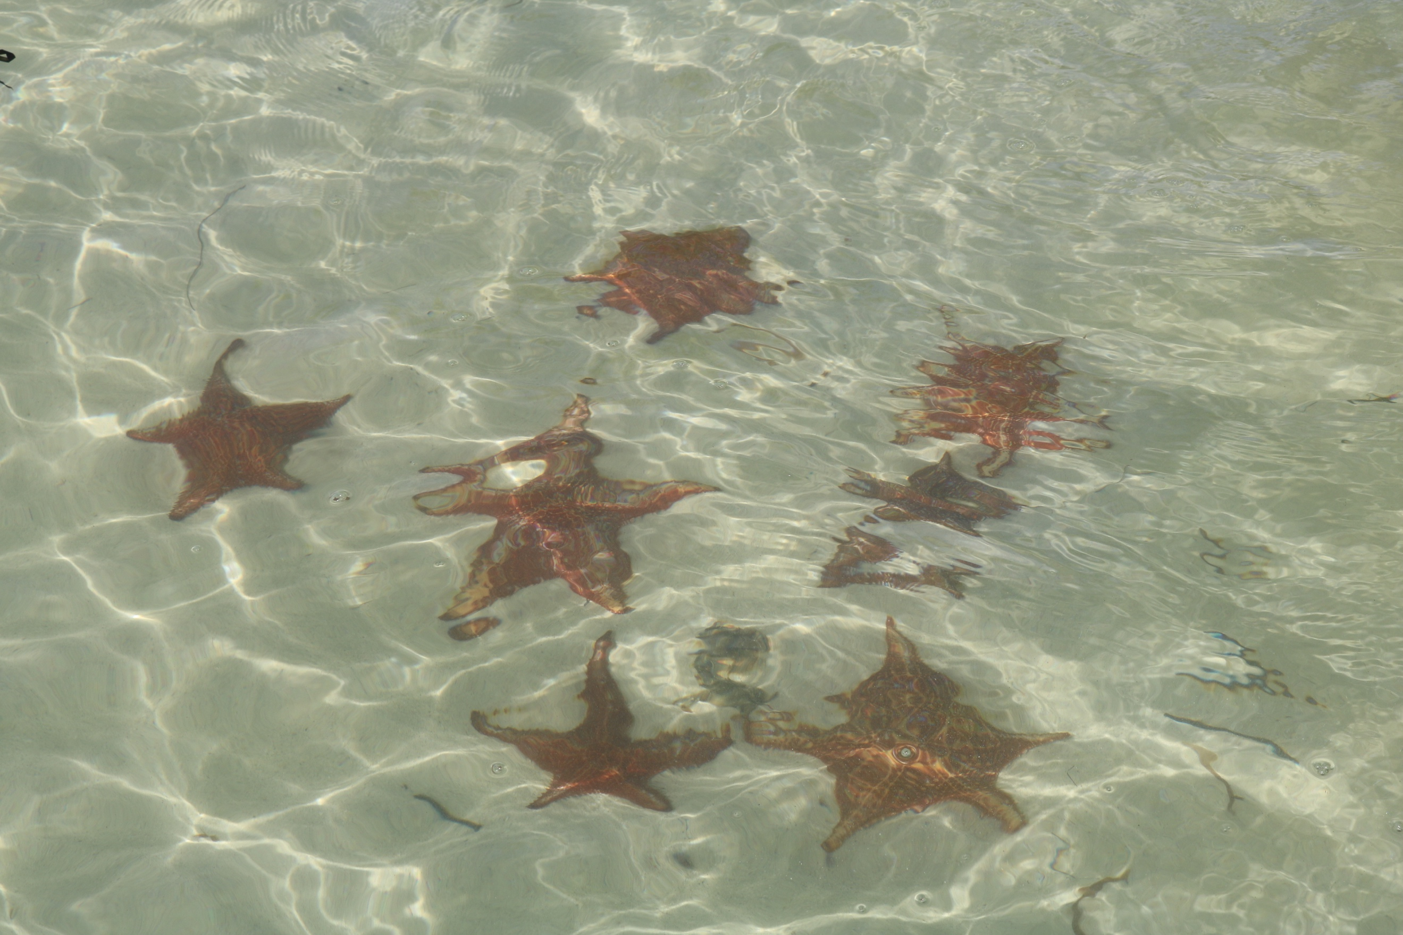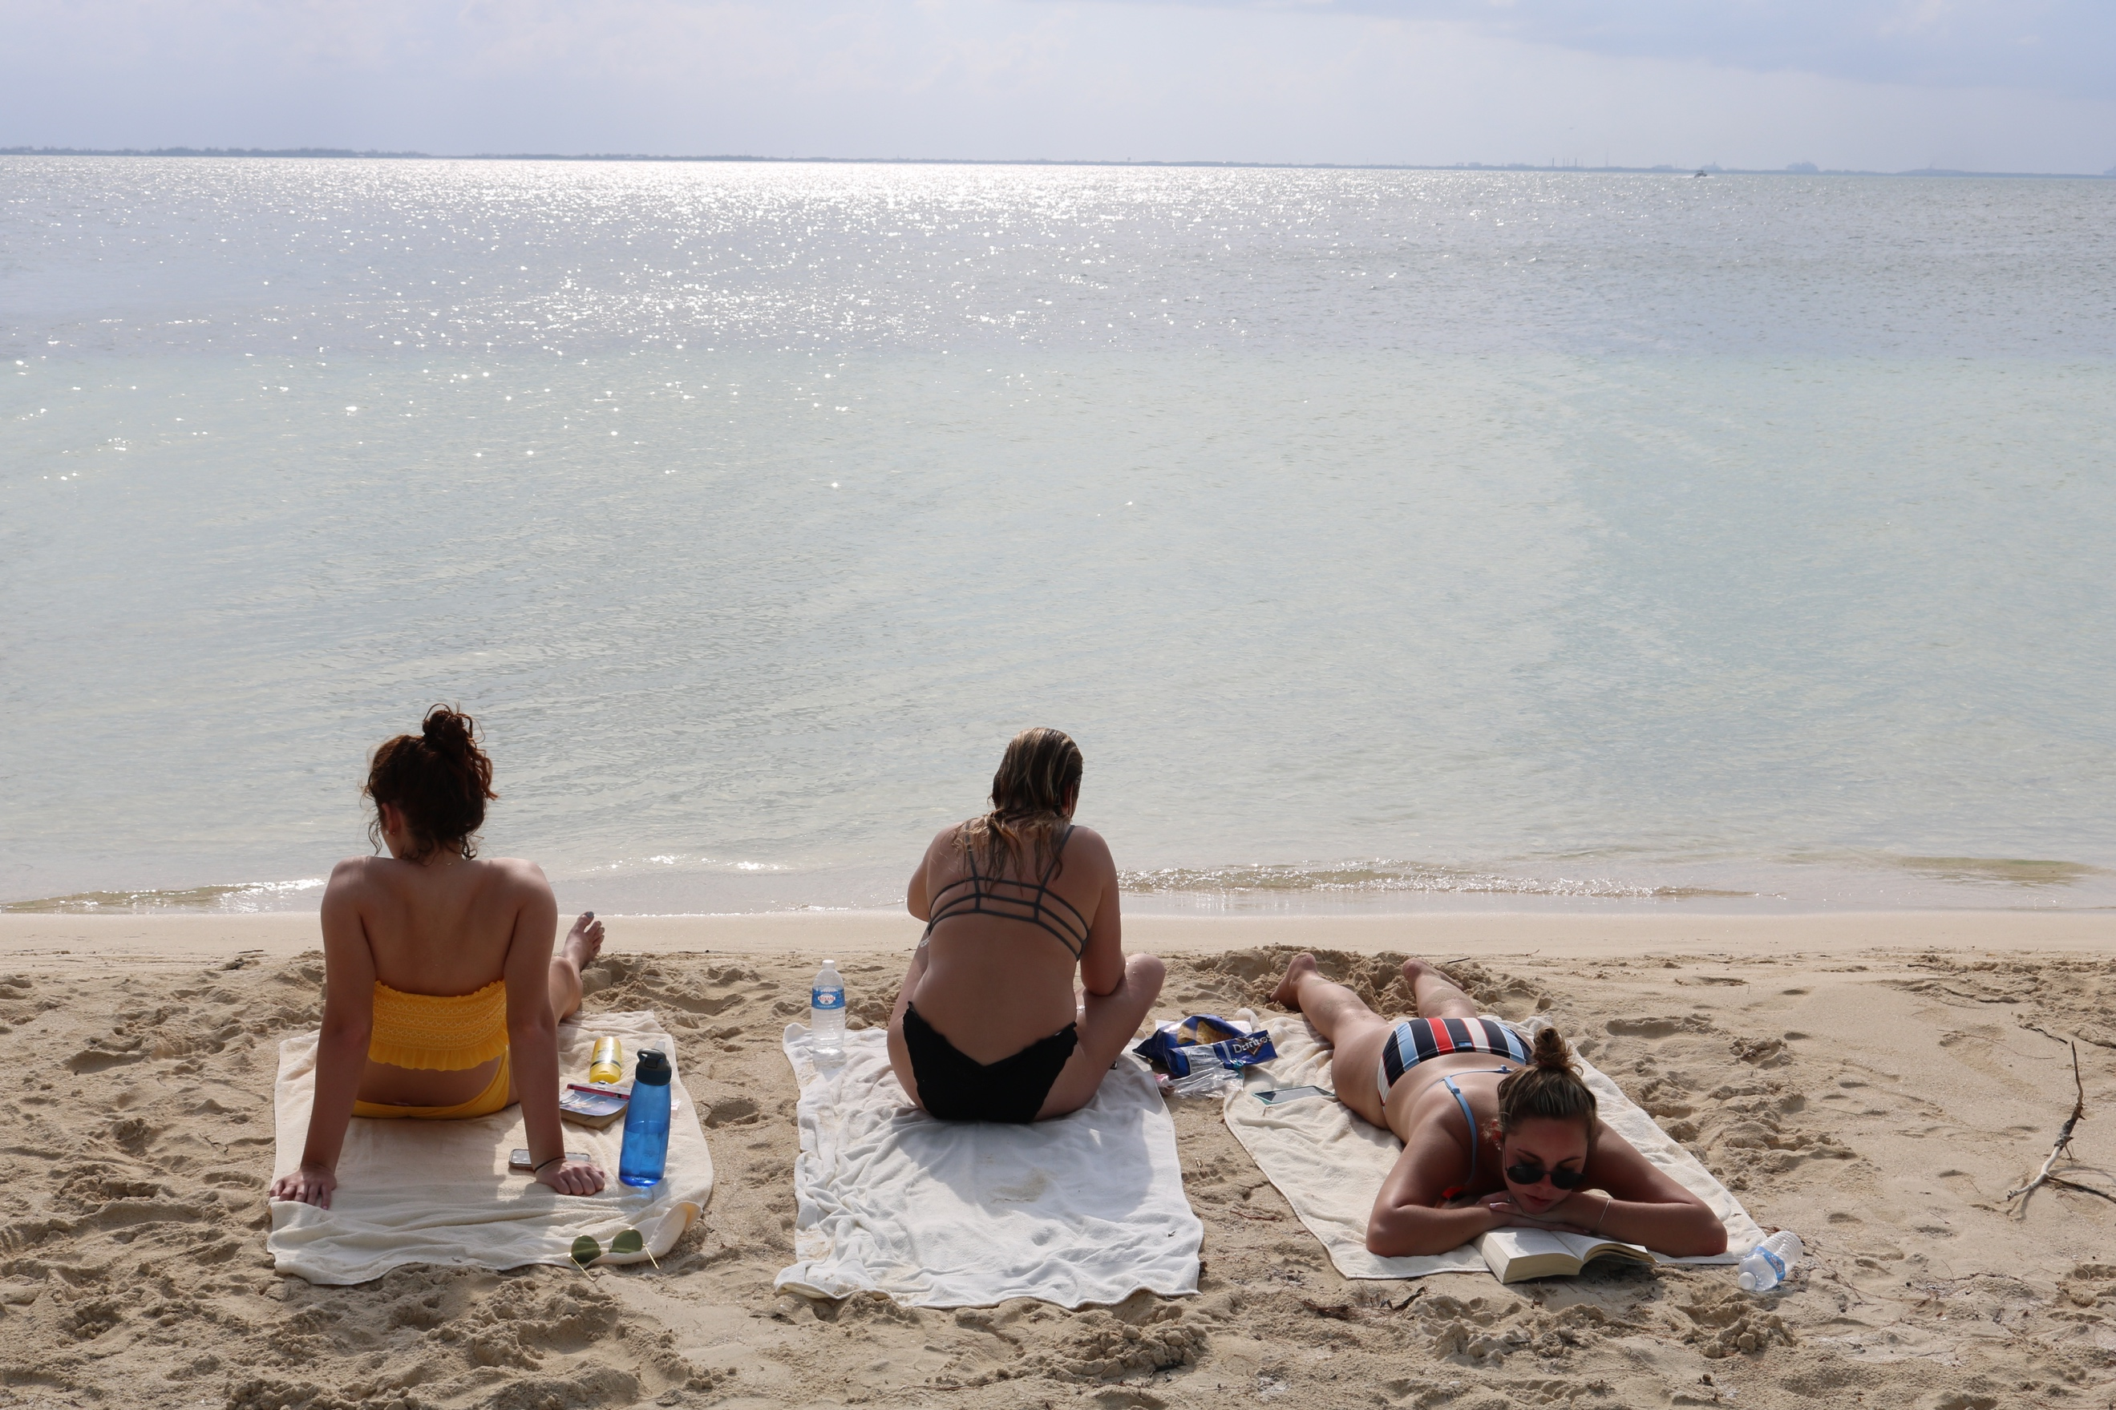

My photos